SE Decarbonization Workshop
Invitation Only:

Nov. 6, 2023:
Lunch and Welcoming Remarks: Noon - 1pm
Lunch Keynote and Intro Comments: 1 - 1:30pm
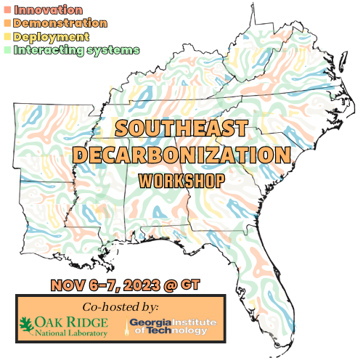
Breakout Sessions Introduction: 1:30 - 2.30pm
Session #1 Innovation: 2.30 - 3.30pm
Coffee Break+ Regrouping: 3.30 - 4pm
Session #2 Demonstration: 4 - 5pm
Insights from Day 1: 5 - 5:30pm
Poster Session and Cocktails: 5:30 – 6:30pm
Dinner with Speaker(s): 6:30 – 8:30pm

Nov. 7, 2023:
Breakfast + Networking: 8:00-9am
Panel Session to Prep for Day 2: 9 - 9:30am
Session #3 Deployment & Scale: 9:30 - 10:30am
Coffee Break+ Regrouping: 10:30 - 11am
Session #4 System of Systems: 11am - Noon
Lunch + Closing Plenary: 12 - 1:30pm
Closed Session – GT/ORNL Initiatives: 1.30pm – 3pm

