Manual for GT-DSM

December 24th , 2014

By:

Benjamin Staver[1]

Alexander Smith[2]

John Sibley[3]

Marilyn Brown[4]

 logo

[http://www.cepl.gatech.edu](http://www.cepl.gatech.edu/) <http://www.southface.org/>



Copyright (C) 2014 Georgia Tech Research Corporation

# Table of Contents

Table of Contents 1

1 Introduction 3

1.1 Model Description 3

1.2 Model Usage 4

1.3 Manual Introduction 4

1.4 Copyright 4

2 Inputs 5

2.1 Customer Sector 6

2.1.1 Customer Sector Base Inputs 6

2.1.2 Rate Impact Module 13

2.1.3 Bill Impact Module 25

2.2 Utility Sector 28

2.2.1 Fundamental Module 28

2.2.2 Performance Incentive Sub-Module 33

2.2.3 Deferred Capital Investment Sub-Module 38

2.2.4 Rate Case Sub-Module 41

2.3 Cost-Benefit Analysis Sector 44

2.3.1 Fundamental Module 44

2.3.2 Discount Rate Sub-Module 45

2.3.3 Avoided Capacity Cost Sub-Module 46

2.3.4 CBA Comparison Sub-Module 47

2.3.5 Other CBA Components Sub-Module 48

3 Calculations 49

3.1 Customer Sector 49

3.1.1 Rate Impact Module 49

3.1.2 Bill Impact Module 53

3.2 Utility Sector 55

3.2.1 Fundamental Sub-Module 55

3.2.2 Performance Incentive Sub-Module 59

3.2.3 Deferred Capital Investment Sub-Module 60

3.3 Cost-Benefit Analysis 62

4 Outputs 65

4.1 Customer Sector 65

4.1.1 Rate Impact Module 65

4.1.2 Bill Impact Module 67

4.2 Utility Sector 69

4.2.1 Utility Impact Module 69

4.2.2 Capital Investment Deferral Module 70

4.3 Cost-Benefit Analysis Sector 72

5 References 74

Glossary 76

# Introduction

The GT-DSM tool is a spreadsheet tool designed to help inform the policy discussion surrounding customer-funded utility-implemented energy efficiency programs in the Southeastern United States. It was designed with three goals in mind: accessibility, accuracy, and relevance. As is the case with all models, perfect accuracy is impossible but the tool aims for enough accuracy to inform policy discussions. The tool has the capacity to provide information in the following areas:

* Comparison of costs of the program to the benefits.
* Levelized cost of energy saved in the program to compare to the cost of supply side alternatives.
* Rate impact of the program and the ultimate bill impact for program participants and non-participants.
* Program impact on earnings and rate of return for the utility.
* Comparison of alternative mechanisms to recover utility costs and incentives.
* Average fuel cost impacts of change in use and period of use of electricity from program savings.

The portal for the GT-DSM tool and this manual is the website for the Georgia Institute of Technology’s Climate and Energy Policy Lab[5].

## Model Description

The model is laid out in Sectors that cover broadly different groups in the energy system. Within each Sector there are various Modules that cover different categories of impacts from energy efficiency programs. Modules may also contain various Sub-Modules that are targeted at specific aspects of energy efficiency program impacts.

There are two Sectors in the tool: the Customer Sector and the Utility Sector. The Customer Sector focuses on the electricity rate and utility bill and how an energy efficiency program affects them. To this end, the Customer Sector has two modules: the Rate Impact Module and the Bill Impact Module.

The Utility Sector focuses on the revenue and costs of the utility and how an energy efficiency program affects them. To this end, the Utility Sector has three modules: the Performance Incentive Module, the Deferred Capital Investment Module, and the Rate Case Module.

The general concept is to allow users to select which Modules and Sub-Modules to use and still provide a useful analysis from the tool. In the case of the Customer Sector, there are also multiple iterations of all of the Modules to allow for multiple Customer Classes with independent energy efficiency programs to be analyzed for one utility. For each Sector, only the Fundamental Sub-Module is mandatory to complete an analysis; all other Sub-Modules are optional but supply potentially valuable data.

## Model Usage

This tool has a wide range of uses. These include evaluating proposed programs or alternative scenarios. The tool is designed to address the areas discussed previously with the outputs given. This tool is not, however, a resource planning tool. The goal of the tool is to inform policy discussions with information on general direction and scale but not real numbers.

The GT-DSM tool has been developed for both the Windows and Mac operating systems. It runs in Microsoft Excel 2007 or later as well as Apache OpenOffice.

## Manual Introduction

The manual for the GT-DSM tool contains three main parts. The first is a description of the inputs. The second section contains brief descriptions of the important calculations carried out within the tool. The final section contains descriptions of the output from the tool, for clarity.

The GT-DSM tool is designed by Sector, Module, and Sub-Module. Each of the three sections is broken down by these categories.

The purpose of this manual is to provide an easy reference for information on the GT-DSM tool. This includes a more in depth description of the components and the terminology as well as the methods chosen for calculations. This should make the tool more accessible than a spreadsheet.

## Copyright

GT-DSM is free software; you can redistribute it and/or modify it under the terms of the GNU General Public License (<http://opensource.org/licenses/GPL-2.0>) as published by the Free Software Foundation.

This program is distributed in the hope that it will be useful, but WITHOUT ANY WARRANTY; without even the implied warranty of MERCHANTABILITY or FITNESS FOR A PARTICULAR PURPOSE. See the GNU General Public License for more details.

 You should have received a copy of the GNU General Public License along with this program; if not, write to the Free Software Foundation, Inc., 59 Temple Place, Suite 330, Boston, MA 02111-1307 USA

 For additional information, contact Professor Marilyn A. Brown, School of Public Policy, Georgia Institute of Technology at [marilyn.brown@pubpolicy.gatech.edu](mailto:marilyn.brown@pubpolicy.gatech.edu), [404-385-0303](tel:404-385-0303).

# Inputs

The inputs for the model are listed within the following section (Section 2) and contain the name of the input and a brief description. Some of the more abstract inputs also list methods or supplementary tools useful in calculating them. The data listed in the images are based on one or more Southeastern utilities and should only be considered examples of possible data.

Many of the inputs requested are accompanied by requests for growth rate assumptions, i.e. rates by which the input value will increase in each year of the model forecast. Source documents and calculation descriptions are suggested to the user for deriving these escalation rates. Users should beware of cases in which historic trends in escalation of any variable may not be commensurate with expected future trends, however. For example, a sudden financial crisis and subsequent recession would cause expected sales growth rates to be much lower in periods following the crisis than the actual growth rates of periods prior to the crisis. Users are advised to take into account reputable sources’ expectations about future trends in relevant variables when deriving growth rate inputs for use in the model.

Some of the values entered as example data can be used as default values. These tend to be the more abstract values such as discount rates. In the case that this is appropriate, some justification of the value is given in the manual. Values should not be used as a default value in cases where utility or program specific data is needed.

The general format is as follows:

Name of Input

Units: The units for the input that the model expects.

Description:

A rough but more detailed description of the input. May include description of averaging method or use in the model.

Example Calculation:

Suggestion of how the input may be calculated from available data.

*May include a formula.*

Source: Known and publicly available source for the data including tips on how to find it. Sources are listed based on the reliability or the data supplied.

## Customer Sector

The Customer Sector contains two modules: the Rate Impact Module and the Bill Impact Module. The bill module relies heavily on the rate module and can only be used roughly on its own.

### Customer Sector Base Inputs

The Customer Sector Base Inputs, shown below for Residential customers, are general inputs used in both the Customer and Utility Sectors of the tool.

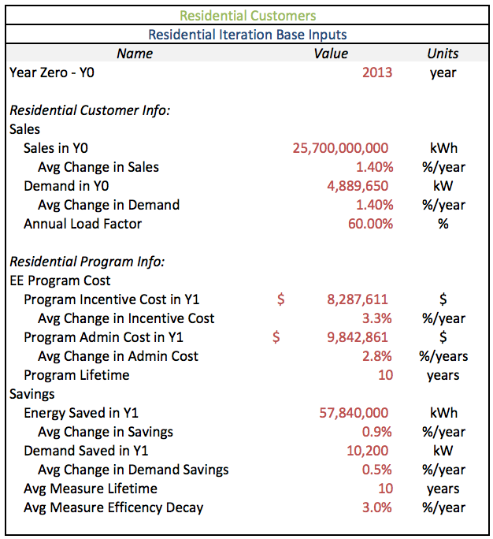

Year Zero – Y0

Units: years

Description:

This input is asking for the year being considered year zero (Y0) in the analysis. By convention, this is being considered the year before the energy efficiency program being evaluated is first implemented. This is used only to identify the years presented in the outputs.

*Customer Info:*

Sales:

Sales in Y0

Units: kWh

Description:

This input is asking for the total retail sales to the customer class[6] (e.g. Residential or Commercial & Industrial). The data does not have to be from the actual year zero but can instead be from the most recent year for which data is available.

Source: [SEC](http://SEC/) [10-K](http://www.sec.gov/edgar/searchedgar/companysearch.html)[7], search Energy Sales

Average Change in Sales

Units: %/year

Description:

This input is asking for the average percent change in sales from year-to-year that is projected for the following years. Either a historical average or a projection by the utility or user can be input.

Example Calculation:

Can be calculated by averaging of the year-to-year change across select years of sales (3-5 years is the norm).

Source: Public Service Commission (PSC) filings such as the Integrated Resource Plan (IRP) or the historical average calculated using [SEC](http://SEC/) [10-K](http://www.sec.gov/edgar/searchedgar/companysearch.html).

Demand in Y0

Units: kW

Description:

This input is asking for the peak demand for the customer class in the most recent year with available data. Demand can be calculated or can be input based on an independent source.

Example Calculation:

Can be calculated using the annual load factor and the total retail sales for the customer class. Divide the total retail sales by the value of the annual load factor multiplied by 8,760, the number of hours per year.

*Demand = Retail Sales / (Annual Load Factor * 8760)*

Source: Possibly available in PSC filings or system wide demand from FERC 714 Schedule 2[8]

Average Change in Demand

Units: %/year

Description:

This input is asking for the average percent change in demand from year-to-year that is projected for the following years without the impact of the program being analyzed; the baseline forecast. Either a historical average or a projection by the utility or user can be input.

Example Calculation:

Can be calculated by averaging the year-to-year change across select years for peak demand (3-5 years is the norm).

Source: Possibly available in PSC filings or utility average calculated using FERC 714 Schedule 2[9]

Annual Load Factor

Units: %

Description:

This input is asking for the percent of the total system capacity that is used throughout the year on average by the customer class. An over all system annual load factor can be used as a proxy from the [SEC](http://SEC/) [10-K](http://www.sec.gov/edgar/searchedgar/companysearch.html).

Source: Possibly available in PSC filings, such as the IRP, or the total system proxy is available in the [SEC](http://SEC/) [10-K](http://www.sec.gov/edgar/searchedgar/companysearch.html).

*Program Info:*

Energy Efficiency Program Cost[10]:

Program Incentive Cost in Y1

Units: $

Description:

This input is asking for the total cost of incentives for the energy efficiency program in its first year. This includes only the costs paid by the utility as incentives to the program participants.

Instead of entering program cost in year one and an average change in incentive cost (see following input), program incentive costs can be entered for each year of the program on the Customer Calculations sheet of the tool[11].

Source: PSC IRP or DSM filings

Average Change in Incentive Cost

Units: %

Description:

This input is asking for the year-to-year percent change in program incentive costs, averaged over the lifetime of the program.

Instead of entering program incentive cost in year one (see previous input) and an average change in incentive cost, program incentive costs can be entered for each year of the program on the Customer Calculations sheet of the tool11.

Example Calculation:

Calculated by averaging the percent change in cost from one year to the next across all available years of program cost[12].

Source: PSC IRP or DSM filings

Program Admin Cost in Y1

Units: $

Description:

This input is asking for the total non-incentive cost of implementing the energy efficiency program in its first year. This includes all costs such as program administration, program marketing, and any other costs paid by the utility that are not incentives to participants.

Instead of entering program admin cost in year one and an average change in admin cost (see following input), program admin costs can be entered for each year of the program on the Customer Calculations sheet of the tool[13].

Source: PSC IRP or DSM filings

Average Change in Admin Cost

Units: %

Description:

This input is asking for the year-to-year percent change in total program non-incentive costs, averaged over the lifetime of the program.

Instead of entering program admin cost in year one (see previous input) and an average change in admin cost, program admin costs can be entered for each year of the program on the Customer Calculations sheet of the tool11.

Example Calculation:

Calculated by averaging the percent change in cost from one year to the next across all available years of program cost[14].

Source: PSC IRP or DSM filings

Program Lifetime

Units: years

Description:

This input is asking for number of years the program will run. This is different from measure lifetime. A program is only considered running when incentives are being offered by the utility.

Source: PSC IRP, DSM filings, or CA DEERE

Savings:

Energy Saved in Y1

Units: kWh

Description:

This input is asking for the total amount of energy saved due to the energy efficiency program in its first year.

Instead of entering the energy saved in year one and an average change in savings (see following input), energy savings can be entered for each year of the program on the Customer Calculations sheet of the tool[15].

Source: PSC IRP or DSM filings

Average Change in Energy Savings

Units: %/year

Description:

This input is asking for the year-to-year percent change in the total program savings, averaged over the lifetime of the program.

Instead of entering the energy saved in year one (see previous input) and an average change in savings, energy savings can be entered for each year of the program on the Customer Calculations sheet of the tool13.

Example Calculation:

Calculated by averaging the percent change in cost from one year to the next across all available years of program energy savings.

Demand Saved in Y1

Units: kWh

Description:

This input is asking for the total amount of power saved due to the energy efficiency program in its first year.

Instead of entering the power saved in year one and an average change in power savings (see following input), power savings can be entered for each year of the program on the Customer Calculations sheet of the tool15.

Source: PSC IRP or DSM filings

Average Change in Demand Savings

Units: %/year

Description:

This input is asking for the year-to-year percent change in the total program power savings, averaged over the lifetime of the program.

Instead of entering the power saved in year one (see previous input) and an average change in power savings, power savings can be entered for each year of the program on the Customer Calculations sheet of the tool15.

Example Calculation:

Calculated by averaging the percent change in cost from one year to the next across all available years of program energy savings.

Average Measure Lifetime

Units: years

Description:

This input is asking for the average lifetime of measures implemented in the program for the customer class, weighted by energy savings.

Example Calculation:

Calculated by averaging the lifetime of each measure weighted by the energy savings of each measure. A supplementary tool is available to help illuminate this calculation[16].

Source: PSC IRP or DSM filings, Measure catalog, a proxy may be derived from DOE data book[17].

Average Measure Efficiency Decay

Units: %/year

Description:

This input is asking for the average percent of energy savings that decay each year after the program has been implemented. This can be used to represent the persistence of installed measures as well as their relative decay.

Source: May be available in PSC filings. Users may also refer to Chapter 13 of NREL/SR-7A30-53827 for guidance[18].

### Rate Impact Module

The Rate Impact Module contains six sub-modules: the fundamental, program cost recovery, lost revenue recovery, levelized cost of energy efficiency, fuel use shift, and deferred capital investment sub-modules.

#### Fundamental Sub-Module

The Fundamental Sub-Module is the core of the rate module and contains the following inputs:

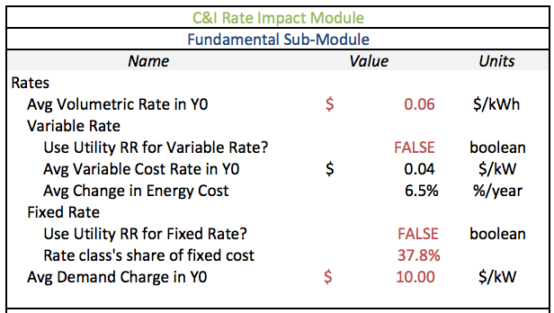

Rates:

Average Volumetric Rate in Y0

Units: $/kWh

Description:

This input is asking for the average number of dollars customers paid for each kWh of energy they bought. This rate (plus the Average Demand Charge in Y0 if used) must account for all revenue to be collected from this customer class and should reflect total revenues filed in the SEC Form 10-K. In asking for the value in year zero, this conventionally means the most recent year for which data is available.

Example Calculation:

Calculated by dividing the total revenue from the rate class by the total retail sales to the rate class. May differ from published rate schedule.

Source: [SEC](http://SEC/) [10-K](http://www.sec.gov/edgar/searchedgar/companysearch.html)

*Variable Rate:*

The tool needs to know the proportion of the average rate that is variable versus fixed to properly calculate the costs and benefits of an energy efficiency program. There are two different methods to calculate this proportion.

Use Utility Revenue Requirement for Variable Cost Rate?

Units: boolean (TRUE/FALSE)

Description:

This input is asking if the utility revenue requirement should be used to calculate the variable cost portion of the average rate or if an entered average variable cost rate should be used. The utility revenue requirement method uses inputs from the Fundamental Module of the Utility Sector of the tool. Using the utility revenue requirements may not capture adjustments as a result of utility rate cases that would be captured with an entered variable cost rate.

Average Variable Cost Rate in Y0

Units: $/kWh

Description:

This input is asking for the average dollars per kWh devoted to paying for costs that vary depending on the amount of energy sold. This is a portion of the total rate asked for in the average rate variable. This input need not be filled out if 'Use Utility RR for Variable Rate?' is marked TRUE.

Example Calculation:

This can be calculated as an average of the fuel costs used by the different generating units weighted by the energy generated by each unit type.

Source: PSC rate case filings or [SEC](http://SEC/) [10-K](http://www.sec.gov/edgar/searchedgar/companysearch.html)

Average Change in Energy Cost

Units: %/year

Description:

This input is asking for the average percent the energy cost changes from year to year for the utility. It is used to adjust the average variable cost rate over the years of the analysis. Either a historical average or a projection by the utility or user can be input. . This input need not be filled out if 'Use Utility RR for Variable Rate?' is marked TRUE.

Example Calculation:

Calculated by averaging the year-to-year change across select years of variables cost (3-5 years is the norm).

Source: PSC rate case filings or [SEC](http://SEC/) [10-K](http://www.sec.gov/edgar/searchedgar/companysearch.html) to calculate a historical average

*Fixed Rate:*

Use Utility Revenue Requirement for Fixed Cost Rate?

Units: boolean (TRUE/FALSE)

Description:

This input is asking if the utility revenue requirement should be used to calculate the fixed cost portion of the average rate or if the difference between the average rate and the average variable rate should be used. Using the utility revenue requirements may not capture adjustments as a result of utility rate cases, which would be captured with an entered variable cost rate.

Rate class’s share of fixed cost

Units: %

Description:

This input is asking for the amount of the utilities total fixed costs that is paid for by the rates of this rate class (residential or commercial and industrial).

Example Calculation:

Calculated by dividing the total fixed revenue from the rate class by the total fixed revenue from all rate classes.

Source: [SEC](http://SEC/) [10-K](http://www.sec.gov/edgar/searchedgar/companysearch.html)

Average Demand Charge in Y0

Units: $/kW

Description:

This input is asking for the average number of dollars customers paid for each kW of power they required during their peak period. In asking for the value in year zero, this conventionally means the most recent year for which data is available.

Source: [SEC](http://SEC/) [10-K](http://www.sec.gov/edgar/searchedgar/companysearch.html) or published rate schedule

#### Program Cost Recovery Sub-Module

The Program Cost Recovery sub-module allows for multiple methods of program cost recovery. It contains the following inputs:

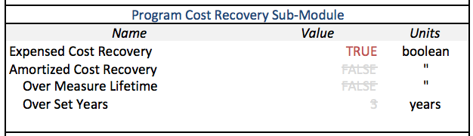

The source of these inputs will usually be rules or rulings of the PSC but the sub-module can also be used to test alternatives scenarios. At most only one method should be marked TRUE at a time.

Expensed Cost Recovery

Units: boolean (TRUE/FALSE)

Description:

This input is asking if the program cost should be recovered as an annual expense across all customers in the customer class.

Amortized Cost Recovery

Units: boolean (TRUE/FALSE)

Description:

This input is asking if the program cost should be recovered as an amortized expense across all customers in the customer class over multiple years.

Over Measure Lifetime

Units: boolean (TRUE/FALSE)

Description:

This input is asking if the amortized program cost should be recovered over a number of years equal to the average lifetime of all measures for the customer class.

Over Set Years

Units: years

Description:

This input is asking over how many years the amortized program cost should be recovered. This is only used if 'Over Measure Lifetime' is marked as FALSE.

#### Lost Revenue Recovery Sub-Module

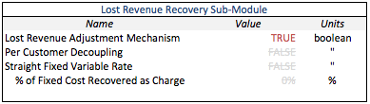The Lost Revenue Recovery sub-module allows for lost revenue to be recovered by the utility through different methods. It contains the following inputs:

The source of these inputs will usually be rules or rulings of the PSC but the sub-module can also be used to test alternatives scenarios. At most only one method should be marked TRUE at a time.

Lost Revenue Adjustment Mechanism

Units: boolean (TRUE/FALSE)

Description:

This input is asking if lost revenues should be recovered across all customers in the customer class using a lost revenue recovery adjustment mechanism[19].

Per Customer Decoupling

Units: boolean (TRUE/FALSE)

Description:

This input is asking if lost revenues should be recovered across all customers in the customer class using a decoupling mechanism based on an allowed revenue per customer19.

Straight Fixed Variables Rate

Units: Boolean (TRUE/FALSE)

Description:

This input is asking if some of fixed revenues should be recovered by applying a single charge to all customers in equal amount regardless of usage.

Percent of Fixed Cost Recovered as Charge

Units: Boolean (TRUE/FALSE)

Description:

This input is asking how much of the fixed costs from the utility should be recovered using the straight fixed charge, if it is selected (see above). If less than 100% is selected then the straight fixed variables rate can be paired with either of the other two lost revenue recovery methods.

#### Levelized Cost of EE Sub-Module

The Levelized Cost of EE sub-module calculates the cost per kWh of the energy efficiency program savings using a discount rate to adjust the value to Y0 dollars. It contains the following inputs:

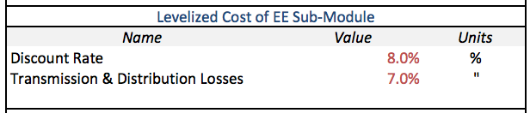

Discount Rate

Units: %

Description:

This input is asking for the amount to discount money for each year in the future it is projected. The suggested standard in this case is the Weighted Average Cost of Capital (WACC).

Example Calculation:

Can be calculated using the following formula:

*WACC = %Debt * CostOfDebt + %Equity * CostOfEquity*

Source: See sources on Cost of Debt (see 2.2) and Cost of Equity or ROE (see 2.2)

Transmission & Distribution Losses

Units: %

Description:

This input is asking for the percent of energy that is lost in transmission and distribution.

Source: EIA Annual Energy Review

#### Fuel Use Shift Sub-Module

The Fuel Use Shift sub-module accounts for the effects of the energy efficiency program savings on average cost of production. Includes both the impact of reduced demand and the shifting of customer load profiles on the average cost of fuel. This effect is a small change in rates but is significant change in bills because it benefits customers across all classes. The inputs for the sub-module are listed below:

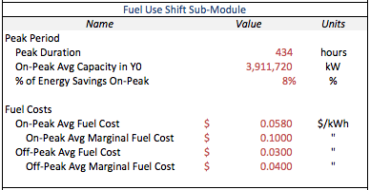

Peak Period:

Peak Duration

Units: hours

Description:

This input is asking for the number of hours that are considered the peak period each year. This and the following input are used to calculate the energy used during the peak period in year zero. It is important to ensure that the cost and capacity throughout the tool be consistent with this definition of the peak period to have maximum accuracy[20].

Source: Individual Utility Policy usually reflected in tariffs[21].

On-Peak Average Capacity in Y0

Units: kW

Description:

This input is asking for the average capacity used during peak hours in year zero. The tool uses the Average Change in Demand (see 2.1) for the growth rate of On-Peak Average Capacity.

Asking for the value in year zero means the most recent year for which data is available, by convention. This and the previous input are used to calculate the energy used during the peak period in year zero.

Example Calculation:

Can be calculated by averaging the value of all hourly demands over the peak period.

Source: PSC filings or FERC 714 Schedule 2[22]

% of Savings On-Peak

Units: %

Description:

This input is asking for the percent of savings from the energy efficiency program that occurs during peak hours. These peak hours should match those defined in the Peak Duration input (see 2.1.1.5).

Example Calculation:

Can be calculated using the supplementary tool. Allows for the entry of individual measures from the EE program. These are entered and aggregated based on end use, which allows for a weighted average of savings calculation based on the savings attributed to each end use and the usage profile of that end use.

Source: OpenEI.org and search for “load” for data and advice[23].

Fuel Costs:

On-Peak Average Fuel Cost

Units: $/kWh

Description:

This input is asking for the utility’s average cost of fuel for the on-peak period. This includes fuel expenses, purchased power expenses, and any variable operations and maintenance (O&M) costs that apply to the peak period.

Example Calculation:

A calculation is only necessary if QF Avoided Cost is not available or if there is doubt of its validity. Can be calculated by fitting a line[24] to the hourly “system lambdas”[25], which represents to marginal cost curve for electricity production. Then the equation for the marginal cost curve should be integrated to get the total cost curve. Finally, use the on-peak average capacity (see 2.1.1.5) to find the average total cost during the peak period and divide it by the on-peak average capacity to get the on-peak average fuel cost.

Source: QF Avoided Cost[26]; FERC 714 for “system lambdas”

On-Peak Average Marginal Fuel Cost

Units: $/kWh

Description:

This input is asking for the utility’s average marginal cost of fuel for the on-peak period. This includes fuel expenses, purchased power expenses, and any variable operations and maintenance (O&M) costs that apply to the peak period.

Example Calculation:

Can be calculated by averaging the hourly “system lambdas”[27] for the peak period. The holding company “system lambda” may be necessary to use but works just as well.

Source: FERC 714 for “system lambdas”

Off-Peak Average Fuel Cost

Units: $/kWh

Description:

This input is asking for the utility’s average cost of fuel for the off-peak period. This includes fuel expenses, purchased power expenses, and any variable operations and maintenance (O&M) costs that apply to the off-peak period.

Example Calculation:

A calculation is only necessary if QF Avoided Cost is not available or if there is doubt of its validity. Can be calculated by fitting a line[28] to the hourly “system lambdas”24, which represents to marginal cost curve for electricity production. Then the equation for the marginal cost curve should be integrated to get the total cost curve. Finally, use the off-peak average capacity to find the average total cost during the off-peak period and divide it by the off-peak average capacity to get the off-peak average fuel cost. The holding company “system lambda” may be necessary to use but works just as well.

Source: QF Avoided Cost[29]; FERC 714 for “system lambdas”

Off-Peak Average Marginal Fuel Cost

Units: $/kWh

Description:

This input is asking for the utility’s average cost of fuel for the off-peak period. This includes fuel expenses, purchased power expenses, and any variable operations and maintenance (O&M) costs that apply to the off-peak period.

Example Calculation:

Can be calculated by averaging the hourly “system lambdas”[30] for the off-peak period. The holding company “system lambda” may be necessary to use but works just as well.

Source: FERC 714 for “system lambdas”

#### Smart Targeting Sub-Module

The Smart Targeting sub-module allows analysis of additional targeting of the EE program. This sub-module is targeted at additional programs beyond those already planned or implemented so inputs are left up to the user to determine and validate.

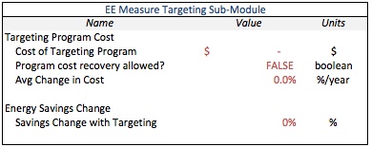

This sub-module is turned off by default and can be left off or turned off again by simply entering zeros and FALSE into all inputs.

Targeting Program Cost:

Cost of Targeting Program

Units: $

Description:

This input is asking for the total cost of the targeting program.

Program cost recovery allowed?

Units: boolean (TRUE/FALSE)

Description:

This input is asking if the utility is allowed to recover the cost of the targeting program from customers.

Average Change in Cost

Units: %/year

Description:

This input is asking for the year-to-year percent change in the cost of the targeting program, averaged over the lifetime of the program.

Energy Savings Change:

Savings Change from Targeting

Units: %

Description:

This input is asking for percent change in the savings achieved based on the new targeting program, averaged over the lifetime of the program.

### Bill Impact Module

The Bill Impact Module contains three sub-modules: the Fundamental, Participation, and the Difference in Participant Average Use sub-modules. The calculations of Bill Impact rely on the Rate Impacts module so the Fundamental sub-module for the Rate Impact module should be completed before starting on the Bill Impact module.

#### Fundamental Sub-Module

The Fundamental Sub-Module is the core of the bill module and contains the following inputs:

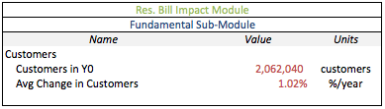

Customers:

Customers in Y0

Units: customers

Description:

This input is asking for the number of customers in the customer class. The data does not have to be from the actual year zero but can instead be from the most recent year for which data is available.

Source: [SEC](http://SEC/) [10-K](http://www.sec.gov/edgar/searchedgar/companysearch.html), search for Results of Operations

Average Change in Number of Customers

Units: %

Description:

This input is asking for the averaged percent change in the number of customers from year-to-year that is projected for the following years. Either a historical average or a projection by the utility or user can be input.

Example Calculation:

Can be calculated by averaging the year-to-year change across select years of customers (3-5 years is the norm).

Source: Possibly available in PSC filings or [SEC](http://SEC/) [10-K](http://www.sec.gov/edgar/searchedgar/companysearch.html).

#### Participation Sub-Module

The Participation sub-module analyzes the difference in the impacts of the energy efficiency program on participants versus non-participants. This sub-module is needed to have any information such differences. The inputs for this sub-module are as follows:

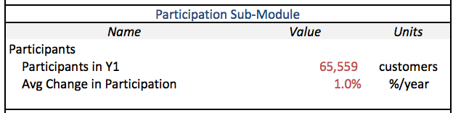

Participants:

Participants in Y1

Units: customers

Description:

This input is asking for the total number of customers participating in the energy efficiency program in its first year.

Instead of entering the number of participants in year one and an average change in participation (see following input), the number of participants can be entered for each year of the program on the Customer Calculations sheet of the tool[31].

Source: IRP or DSM filings

Average Change in Participation

Units: %

Description:

This input is asking for the year-to-year percent change in the number of customers participating in the program, averaged over the lifetime of the program.

Instead of entering the number of participants in year one (see previous input) and an average change in participation, the number of participants can be entered for each year of the program on the Customer Calculations sheet of the tool15.

Example Calculation:

Calculated by averaging the year-to-year change across all years of the program.

Source: IRP or DSM filings

#### Difference in Participant Average Use Sub-Module

The Difference in Participant Average Use sub-module is used to account for a difference between the average use for all customers in the class and the average use of those who participate in the energy efficiency program. This is to ensure that the impact on the non-participant usage and bills is accurately calculated. This sub-module is discretionary and need not be used if the data is unavailable. To do so, simply enter zero for the input. The inputs are as follows:

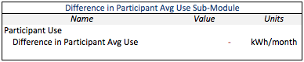

Participant Use:

Difference in Participant Average Use

Units: kWh

Description:

This input is asking for the difference between the average energy used by participating customers and the average energy used by all customers. If this value is zero, this serves to turn off the sub-module.

Example Calculation:

Can be calculated by subtracting the value of all sales divided by the number of customers from the average use of program participants.

Source: Most likely available in an EM&V study.

## Utility Sector

The Utility Sector contains four modules: the Fundamental Module, the Performance Incentive Module, the Deferred Capital Investment Module and the Rate Case Module.

### Fundamental Module

The Fundamental Sub-Module is the core of the Utility Sector and contains the following inputs used in both the Customer and Utility Sector to characterize the electric utility deploying the DSM program:

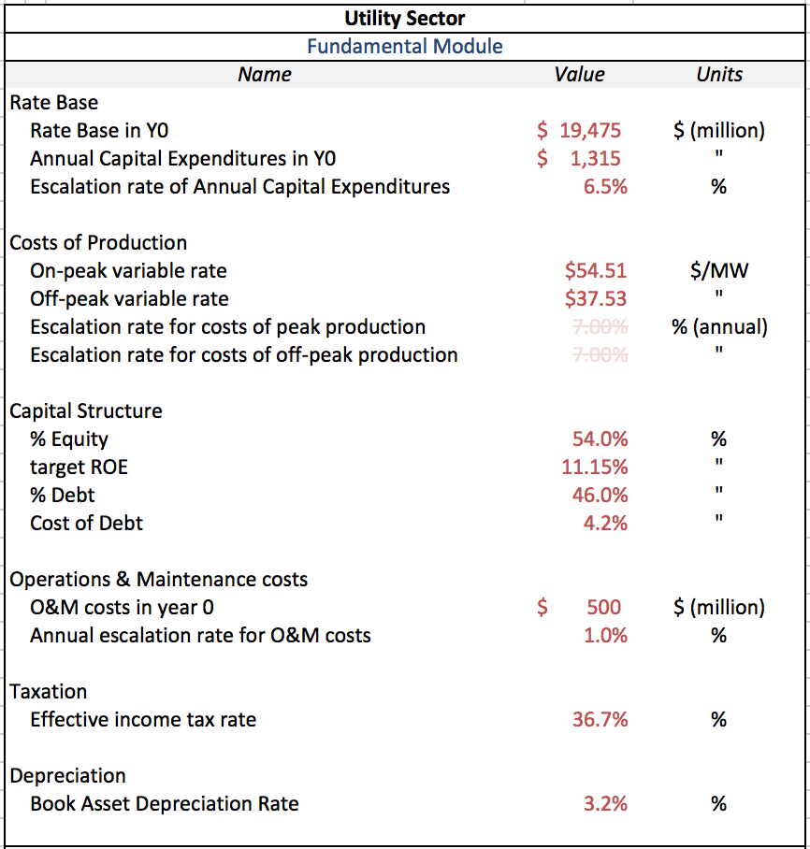

Rate Base:

Rate Base in Y0

Units: $ (million)

Description:

This input is asking for the total dollar value in year zero of the assets on which the public service commission allows the utility firm to collect revenues and recover costs. The data does not have to be from the actual year zero but can instead be from the most recent year for which data is available. Entered in millions of dollars. Where the direct value is unavailable, plant-in-service net of depreciation can be used as a proxy, which can usually be found in the SEC 10-K

Source: PSC filings; [SEC](http://SEC/) [10-K](http://www.sec.gov/edgar/searchedgar/companysearch.html)

Annual Capital Expenditures in Y0

Units: $ (million)

Description:

This input is asking for the total amount that the utility firm spends upon maintaining its infrastructure in year zero. This does not include new plant construction. The data does not have to be from the actual year zero but can instead be from the most recent year for which data is available.

Source: [SEC](http://SEC/) [10-K](http://www.sec.gov/edgar/searchedgar/companysearch.html)

Escalation Rate of Annual Capital Expenditures

Units: %

Description:

This input is asking for the average percent change in capital expenditure from year-to-year that is projected for the following years. Either a historical average or a projection by the utility or user can be input.

Example Calculation:

Can be calculated by averaging the year-to-year in capital expenditures across selected years (3-5 years is the norm).

Source: PSC filings for projections or [SEC](http://SEC/) [10-K](http://www.sec.gov/edgar/searchedgar/companysearch.html) for historical average.

Cost of Production:

On-Peak Costs of Production

Units: $/MWh

Description:

This input is asking for the utility’s average costs of production for the on-peak periods. This includes fuel expenses, purchased power expenses, and any variable operations and maintenance (O&M) costs that apply to the peak period.

Example Calculation:

A calculation is only necessary if QF Avoided Cost is not available or if there is doubt of its validity. Can be calculated by averaging the hourly “system lambdas”[32] for the peak period.

Source: QF Avoided Cost[33], FERC 714 for “system lambdas”

Off-Peak Costs of Production

Units: $/MWh

Description:

This input is asking for the utility’s average costs of production for the off-peak periods. This includes fuel expenses, purchased power expenses, and any variable O&M costs that apply to the off-peak period.

Example Calculation:

A calculation is only necessary if QF Avoided Cost is not available or if there is doubt of its validity. Can be calculated by averaging the hourly “system lambdas”17 for the off-peak period.

Source: QF Avoided Cost filings18, FERC 714 for “system lambdas”

Escalation Rate for Costs of Peak Production

Units: %

Description:

This input is asking for the average percent change in the utility’s cost of peak production from year-to-year is projected for future years. Either a historical average or a projection by the utility or user can be input.

Example Calculation:

Can be calculated by averaging the year-to-year change across select years of peak production costs (3-5 years in the norm). The user can also use EIA projections of natural gas price escalation rates as a proxy.

Source: QF Avoided Cost filings; EIA projections or historical fuel price data.

Escalation Rate for Costs of Off-Peak Production

Units: percentage

Description:

This input is asking for the average percent change in the utility’s cost of peak production from year-to-year is projected for future years. Either a historical average or a projection by the utility or user can be input.

Example Calculation:

Can be calculated by averaging the year-to-year change across select years of peak production costs (3-5 years in the norm). The user can also use EIA projections of natural gas price escalation rates as a proxy.

Source: QF Avoided Cost filings; EIA projections or historical fuel price data.

Capital Structure:

% Equity

Units: percentage

Description:

This input is asking for the percent of the utility firm’s capital structure, i.e. financial assets, that is made up by equity. At a high level, utility firms can divide their capital structure into equity and debt.

Source: PSC filing, [SEC](http://SEC/) [10-K](http://www.sec.gov/edgar/searchedgar/companysearch.html).

Target ROE

Units: percentage

Description:

This input is asking for the Return on Equity (ROE) that the public service commission authorizes for the utility firm. This is analogous to the utility firm’s cost of equity.

Source: PSC filings, [SEC](http://SEC/) [10-K](http://www.sec.gov/edgar/searchedgar/companysearch.html).

% Debt

Units: percentage

Description:

This input is asking for the percent of the utility firm’s capital structure, i.e. financial assets, that is made up by long-term debt. At a high level, utility firms can divide their capital structure into equity and debt.

Source: PSC filings, [SEC](http://SEC/) [10-K](http://www.sec.gov/edgar/searchedgar/companysearch.html).

Cost of Debt

Units: percentage

Description:

This input is asking for the interest rate or cost of debt on the utility firm’s long-term debt.

Source: PSC filings, [SEC](http://SEC/) [10-K](http://www.sec.gov/edgar/searchedgar/companysearch.html).

Operation and Maintenance (O&M) Costs:

O&M Costs in Y0

Units: $ (million)

Description:

This input is asking for the annual expenditures on fixed O&M in year zero. This includes only fixed O&M. Any variable O&M reported by the utility should be included in the costs of production input above.

Example Calculation:

This input may require summing relevant categories, such as “plant maintenance”, “transmission maintenance”, and “billing operations.” The O&M costs may not be reported as one category in the source documents.

Source:

Usually listed as a line item in PSC filings and [SEC](http://SEC/) [10-K](http://www.sec.gov/edgar/searchedgar/companysearch.html).

Annual Escalation Rate for O&M Costs

Units: percentage

Description:

This input is asking for the rate at which O&M expenditures are expected to increase in each year.

Example Calculation:

This input can be taken directly from public service commission documents, where provided. Alternatively, users may estimate the historic rate of change in O&M costs from an appropriate time series of values.

Source:

PSC filings; [SEC](http://SEC/) [10-K](http://www.sec.gov/edgar/searchedgar/companysearch.html).

Taxation:

Effective Income Tax Rate

Units: percentage

Description:

This input is asking for the percent of annual earnings that is paid out in taxes to the federal and state governments.

Source: PSC filings or [SEC](http://SEC/) [10-K](http://www.sec.gov/edgar/searchedgar/companysearch.html).

Depreciation:

Book Asset Depreciation Rate

Units: percentage

Description:

This input is asking for the percent by which assets are depreciated on the utility firm’s balance sheet, i.e. “on the books.”

Source: [SEC](http://SEC/) [10-K](http://www.sec.gov/edgar/searchedgar/companysearch.html) or PSC filings.

### Performance Incentive Sub-Module

The Performance Incentive Module is intended to capture additional impacts from common forms of incentive programs offered by Public Service Commissions to utility firms. Performance incentive programs provide additional revenues to the utility as a reward for engaging in DSM programs. The types of performance incentive programs modeled by this sub-module are styled after descriptions in the National Action Plan on Energy Efficiency’s “Aligning Utility Incentives with Investment in Energy Efficiency,” published by the EPA and available at <http://www.epa.gov/cleanenergy/energy-programs/suca/resources.html>

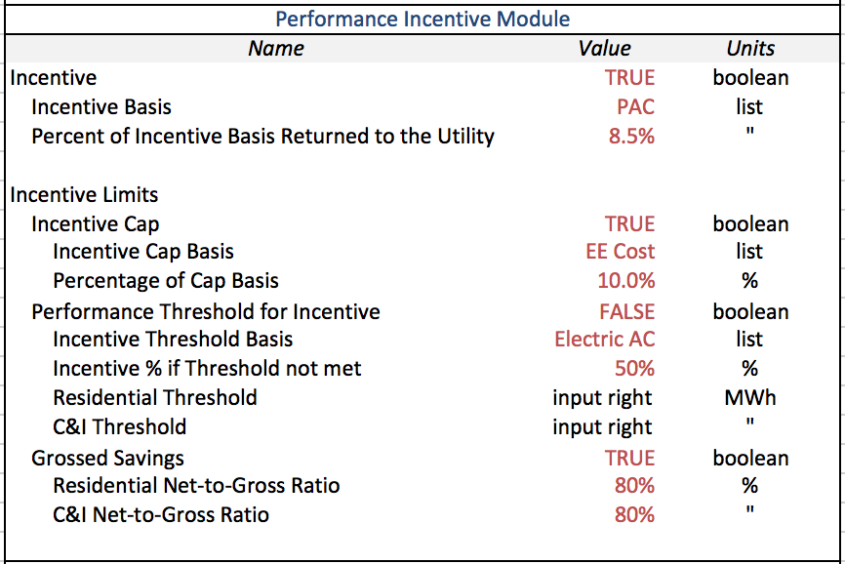

Incentive:

Units: Boolean

Description:

This input is asking whether or not the utility is offered an Incentive for its DSM program. This is additional money that is awarded as a percentage of a CBA test or the costs of the DSM program.

Source:

This value is determined by whether or not the public service commission plans to offer such an incentive to the utility, or whether the user is interested in testing such incentives with the model in order to observe the effects upon utility earnings and ROE.

Incentive Basis

Units: Drop-down menu selection

Description:

This input is asking for what the incentive given to the utility will be based on. These can be selected from a dropdown list and are the four CBA tests and program costs. This variable in then used, together with the Percent of Incentive Basis Returned to the Utility (see below), to calculate the incentive collected by the utility, subject to the Incentive Limits (see input section below), which is then collected over all sales.

Source:

This value can be taken from public service commission documents, if the utility already receives an incentive. Alternatively, various bases for incentives can be tested to observe their effects upon the utility.

Percent of Incentive Basis Returned to the Utility

Units: Percentage

Description:

This input is asking for what percentage of the Incentive Basis (see above input) the utility will receive, subject to the Incentive Limits (see input section below), which is then collected over all sales.

Source:

This value can be taken from public service commission documents, if the utility already receives an incentive. Alternatively, various percentages can be tested to observe the effects of an incentive upon the utility.

Incentive Limits:

*Incentive Cap*

Units: Boolean

Description:

This input is asking whether or not the utility’s Incentive is capped. This is based simply on whether the public service commission has authorized a cap on the incentives for a utility or if the user is interested in testing such a cap.

Source: PSC filings

Incentive Cap Basis

Units: Drop-down menu selection

Description:

This input is asking for the basis of the Incentive Cap. This can be selected from a dropdown list and the available options are the four CBA tests and program costs. This variable in then used, together with the Percent of Incentive Cap Basis (see below), to calculate the Incentive Cap. This is based simply on what the public service commission has authorized as a basis for an incentive cap for the utility or if the user is interested in testing such a cap.

Source: PSC filings

Percentage of Incentive Cap Basis

Units: Percentage

Description:

This input is asking for the percentage of the Incentive Cap Basis (see above input) that the utility will be capped based on. This is based on what the public service commission has authorized as a percentage of incentive cap basis for the utility or if the user is interested in testing such a cap.

Source: PSC filings

*Performance Threshold for Incentive*

Units: Boolean

Description:

This input is asking whether or not the utility’s Incentive has a performance threshold that must be met before receiving their full Incentive. This is based simply on whether the public service commission has authorized a cap on the incentives for a utility or if the user is interested in testing such a threshold.

Source: PSC filings

Incentive Threshold Basis

Units: Drop-down menu selection

Description:

This input is asking for the basis of the Incentive threshold. This can be selected from a dropdown list and the available options are electric avoided cost, the program costs, or the TRC, PAC, or PCT CBA tests. This variable in then used, together with the Residential or C/I Threshold (see below), to determine if the program met the expectations in each year. This is based simply on what the public service commission has authorized as a basis for an incentive threshold for the utility or if the user is interested in testing such a threshold.

Source: PSC filings

Incentive Percent if Threshold is not met

Units: Percentage

Description:

This input is asking for the percentage of the Incentive that the utility will be given if the program performance doesn’t meet the threshold. This is based on what the public service commission has authorized as a percentage of incentive for the utility if the threshold is not met or if the user is interested in testing such a threshold.

Source: PSC filings

Residential Threshold

Units: $

Description:

This input is asking for the threshold value for the Incentive Threshold Basis that the utility must meet in its Residential program to be given the full incentive. If the program performance doesn’t meet the threshold then the utility is given a reduced incentive based on the Incentive Percent if Threshold is not met (see above). These are entered annually in a separate table to the right of the normal input table (see below). This is based on what the public service commission has authorized as a threshold for the utility or if the user is interested in testing such a threshold.

Source: PSC filings

C&I Threshold

Units: $

Description:

This input is asking for the threshold value for the Incentive Threshold Basis that the utility must meet in its Commercial and Industrial programs to be given the full incentive. If the program performance doesn’t meet the threshold then the utility is given a reduced incentive based on the Incentive Percent if Threshold is not met (see above). These are entered annually in a separate table to the right of the normal input table (see below). This is based on what the public service commission has authorized as a threshold for the utility or if the user is interested in testing such a threshold.

Source: PSC filings

*Thresholds:*

The annual values for the performance threshold are entered in the table that appears as the following:

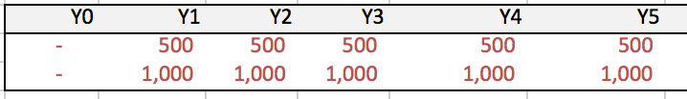

*Grossed Savings*

Units: Boolean

Description:

This input is asking whether or not the utility’s DSM program savings are grossed instead of just netted for the purpose of the Incentive. This is based simply on whether the public service commission has authorized a cap on the incentives for a utility or if the user is interested in testing such a cap.

Source: PSC filings

Residential Net-to-Gross Ratio

Units: Percentage

Description:

This input is asking for the percentage that the grossed savings are of the net savings in the Residential program. This is based simply on whether the public service commission has authorized a cap on the incentives for a utility or if the user is interested in testing such an incentive limiter.

Source: PSC filings

C&I Net-to-Gross Ratio

Units: Percentage

Description:

This input is asking for the percentage that the grossed savings are of the net savings in the Commercial and Industrial programs. This is based simply on whether the public service commission has authorized a cap on the incentives for a utility or if the user is interested in testing such an incentive limiter.

Source: PSC filings

### Deferred Capital Investment Sub-Module

The Deferred Capital Investment Sub-Module is intended to capture impacts of DSM programs to a utility firm’s major capital investment projects. The utility may be planning to build new power supply infrastructure that could be avoided through energy efficiency, and the user can specify the costs and timing of such future projects in this sub-module.



Forecasted Capital Investment:

Note: the descriptions of this input apply to Capital Investment A, B, C, D, and E in this section of the utility sector worksheet. This section of the model can also be used to characterize capital costs related to environmental compliance, such as emissions control technologies applied to power plants.

Capital Investment A

Units: Boolean

Description:

This input is asking whether a major capital investment (new power plants or a new transmission system) are expected to be made during the forecast period.

Source: The user should refer to both [SEC](http://SEC/) [10-K](http://www.sec.gov/edgar/searchedgar/companysearch.html) filings and public service commission documents in order to verify whether the utility firm expects to make a major capital investment. The user may experiment with this value in order to observe the effects of a new capital investment upon all stakeholders.

Name

Units: words

Description:

This input is asking the user to name the capital investment.

Source: If seeking to model expected capital investments, users should use the name of the capital investment project as it is described in [SEC](http://SEC/) [10-K](http://www.sec.gov/edgar/searchedgar/companysearch.html)s and public service commission documents. Any name will suffice for experimental purposes.

Activation Year

Units: Integer, from 1 to 25

Description:

This input is asking the user to identify the first year in which the capital investment will be used. For example, the point at which a power plant goes into service and begins generating electricity would be the activation year for a power plant capital investment.

Source: If seeking to model expected capital investments, users should use the expected activation year described by [SEC](http://SEC/) [10-K](http://www.sec.gov/edgar/searchedgar/companysearch.html)s and public service documents. Any year will suffice for experimental purposes.

Cost Recovery Time Series

Units: $ (million)

Description:

This input asks the user to identify the amount of the capital investment’s costs that will be recovered in each year. These values are to be entered into the time-series rows to the right of the input descriptions. These costs can be recovered prior to the activation year or after the activation year. The user must specify a value for each year, using zero if no costs from the investment will be recovered in that year.

Source: If seeking to model expected capital investments, users should use the any information available from [SEC](http://SEC/) [10-K](http://www.sec.gov/edgar/searchedgar/companysearch.html)s and public service documents to identify the expected schedule of cost recovery.



### Rate Case Sub-Module

The Rate Case Sub-module is intended to capture the effects of different styles of rate case proceedings among various Public Service Commissions. While some Public Service Commissions hold rate cases on the basis of passing years, other Public Service Commissions respond to extreme changes in the utility’s ROE by holding rate cases.

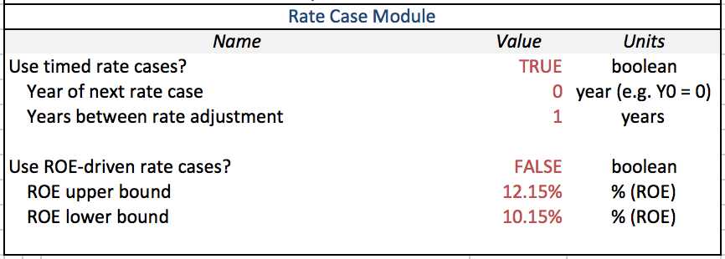

Use Timed Rate Cases?

Units: Boolean

Description:

This input is asking whether the public service commission holds rate case hearings periodically, simply on the basis of the number of years since the prior rate case. There may not be a formal rule about the timing of rate cases, in which case the history of rate case activity can be used to form an appropriate value.

Source: PSC filings and PSC rules of governance.

Year of Next Rate Case

Units: Integer

Description:

This input is asking in what year of the forecast period (e.g. 0, 1, 2, 3…) the next rate case is expected to be held.

Source: The user should refer to public service commission dockets, histories of rate case behavior by the public service commission, and the public service commission code in order to identify the year of the next upcoming rate case.

Years Between Rate Cases

Units: Integer

Description:

This input is asking for what the normal duration between rate cases is in the number of years.

Source: The user should refer to public service commission dockets, histories of rate case behavior by the public service commission, and the public service commission code in order to identify the usual number of years between rate cases.

Use ROE-Driven Rate Cases?

Units: Boolean

Description:

This input is asking whether the public service commission uses the ROE to determine when rate cases will be held.

Source: The user should refer to public service commission dockets, histories of rate case behavior by the public service commission, and the public service commission code in order to identify whether the utility firm’s ROE determines whether or not a rate case will be held in a given year.

ROE Upper Bound

Units: percentage

Description:

This input asks what value of ROE must be exceeded before a rate case will be held. If the utility’s ROE – measuring the profits of the utility firm – exceed the ROE Upper Bound, it signals that the utility is earning much more in revenue than its costs of supply. The model assumes a rate case is held and adjusts rates so that the utility’s earnings are commensurate with its costs of supply.

Source: The user should refer to public service commission dockets, histories of rate case behavior by the public service commission, and the public service commission code in order to identify the ROE upper bound used by the public service commission.

ROE Lower Bound

Units: percentage

Description:

This input asks below what value of ROE the utility’s ROE must fall short before a rate case will be held. If the utility’s ROE – measuring the profits of the utility firm – falls below the ROE Lower Bound, it signals that the utility is earning less in revenue than its costs of supply. The model assumes a rate case will be held and adjusts rates so that the utility’s earnings are commensurate with its costs of supply.

Source: The user should refer to public service commission dockets, histories of rate case behavior by the public service commission, and the public service commission code in order to identify the ROE lower bound used by the public service commission.

## Cost-Benefit Analysis Sector

The Cost-Benefit Analysis (CBA) Sector contains two modules: the Fundamental Module and the Adjustment Module. The Fundamental module collects from the user inputs that are necessary to compute CBA tests and that have not already been collected in other sectors. The Discount Rate sub-module allows the user to set the discount rate for each of the tests separately. The Avoided Capacity Cost sub-module allows the user to enter additional savings beyond those calculated in the tool, such as capacity savings based on the demand savings. CBA Comparison sub-module allows the user to enter the CBA results reported by the utility to make for easy comparison with those from the tool. Finally, the Other CBA Component sub-module allows the user to enter additional component for the different test to tailor them to individual states standard practices.

### Fundamental Module

The Fundamental Sub-Module is the core of the Cost-Benefit Analysis sector and contains the following inputs:

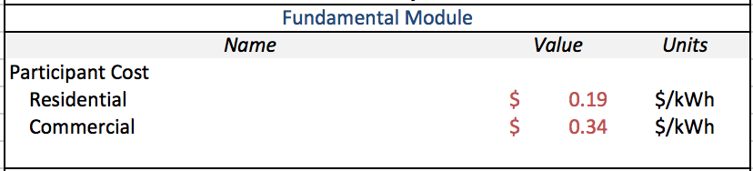

*Participant Cost:*

Residential

Units: $/kWh

Description:

This input is asking for the cost that Residential participants paid above and beyond what they would otherwise have paid per kWh of savings. This should not include the amount paid in incentives so it would be the net amount paid above and beyond the expected amount paid. This is used in the participant cost test to calculate the total participant cost.

Example Calculation:

This value is generally reported by the utility for the different measures proposed but if not, or if a new program is being constructed, the following explains how one would calculate it.

First, you would find the value participants paid by taking the total cost of the final implemented measure and subtract both the cost of the measure that would otherwise have been installed and the incentive paid to the participant by the utility. You then take this value and divide it by the total savings expected for the lifetime of the measure.

Source: PSC filings

Commercial & Industrial

Units: $/kWh

Description:

This input is asking for the cost that Commercial and/or Industrial participants paid above and beyond what they would otherwise have paid per kWh of savings. This should not include the amount paid in incentives so it would be the net amount paid above and beyond the expected amount paid. This is used in the participant cost test to calculate the total participant cost.

Example Calculation:

This value is generally reported by the utility for the different measures proposed but if not, or if a new program is being constructed, the following explains how one would calculate it.

First, you would find the value participants paid by taking the total cost of the final implemented measure and subtract both the cost of the measure that would otherwise have been installed and the incentive paid to the participant by the utility. You then take this value and divide it by the total savings expected for the lifetime of the measure. Source: PSC filings

Source: PSC filings

### Discount Rate Sub-Module

The Discount Rate sub-module allows for the value in the CBA to be discounted. It allows for a different discount rate for each test in the suite of analyses. The inputs for the sub-module are as follows:

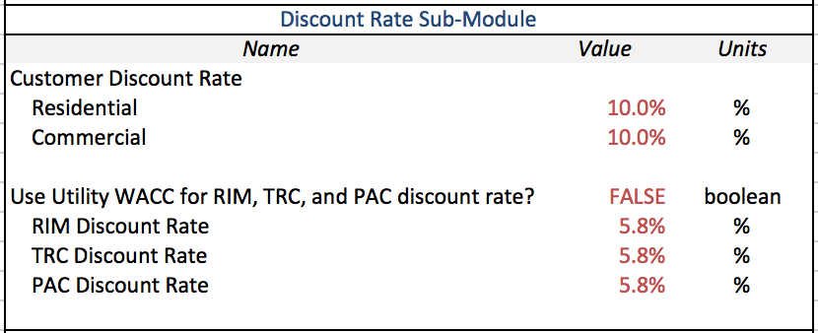

*Customer Discount Rate:*

Residential:

Units: %

Description:

This input is asking for the amount, in percent, by which Residential customers discount money for each year in the future that it is.

Source: ???

C/I:

Units: %

Description:

This input is asking for the amount, in percent, by which Commercial and Industrial customers discount money for each year in the future that it is. The Weighted Average Cost of Capital (WACC) is one possibility but need not be the standard.

Source: ???

Use Utility WACC for RIM, TRC, and PAC discount rate?:

Units: boolean (TRUE/FALSE)

Description:

This input is asking if the value of the utility’s Weighted Average Cost of Capital (WACC) should be used in calculating the RIM, TRC, and PAC tests.

Source: PSC filings

[TEST] Discount Rate:

Units: %

Description:

This input is asking for the percent by which future money should be discounted for each non-participant test. These are the RIM, TRC, and PAC tests. These can all be the same value for each test or can be varied between tests depending on the standard practice.

Source: PSC filings

### Avoided Capacity Cost Sub-Module

The Avoided Capacity Cost sub-module allows the user to enter additional program savings not calculated in the model for the purpose of the CBA tests. Specifically, the savings can be based on the amount of demand/power or the amount of energy that is saved in the program. The inputs for the sub-module are as follows:

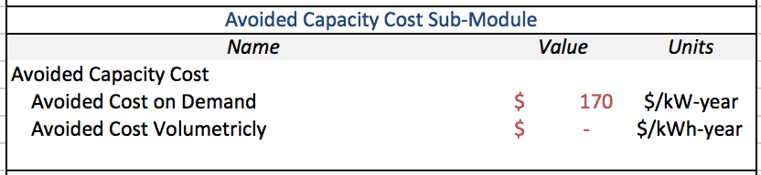

*Avoided Capacity Cost:*

Avoided Cost in Demand:

Units: $/kW-year

Description:

This input is asking for the cost related to capacity that is saved per kW in a single year.

Example Calculation:

This may be calculated by dividing the total amount of capacity cost savings by the total amount of demand saved.

Source: PSC filings

Avoided Cost Volumetrically:

Units: $/kWh-year

Description:

This input is asking for the cost related to capacity that is saved per kWh in a single year.

Example Calculation:

This may be calculated by dividing the total amount of capacity cost savings by the total amount of energy saved.

Source: PSC filings

### CBA Comparison Sub-Module

The CBA Comparison sub-module allows for the easy comparison between the CBA values calculated in the tool with the CBA values reported by the utility. This can be used either as a validation for the tool results or as a critical comparison between the two. The inputs for the sub-module are as follows:

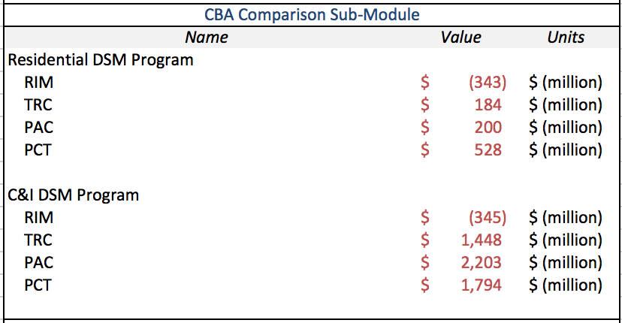

*DSM Program:*

[TEST] (RIM, TRC, PAC, or PCT):

Units: $ (million)

Description:

This input is asking for the CBA results reported by the utility for each of the four tests calculated by the tool for the Residential and the C/I programs. These should not be calculated but taken straight from the data supplied by the utility.

Source: PSC filings

### Other CBA Components Sub-Module

The Other CBA Components sub-module allows the user to enter any additional costs or benefits to the CBA calculations to tailor them to specific practices. The inputs for the sub-module are as follows:

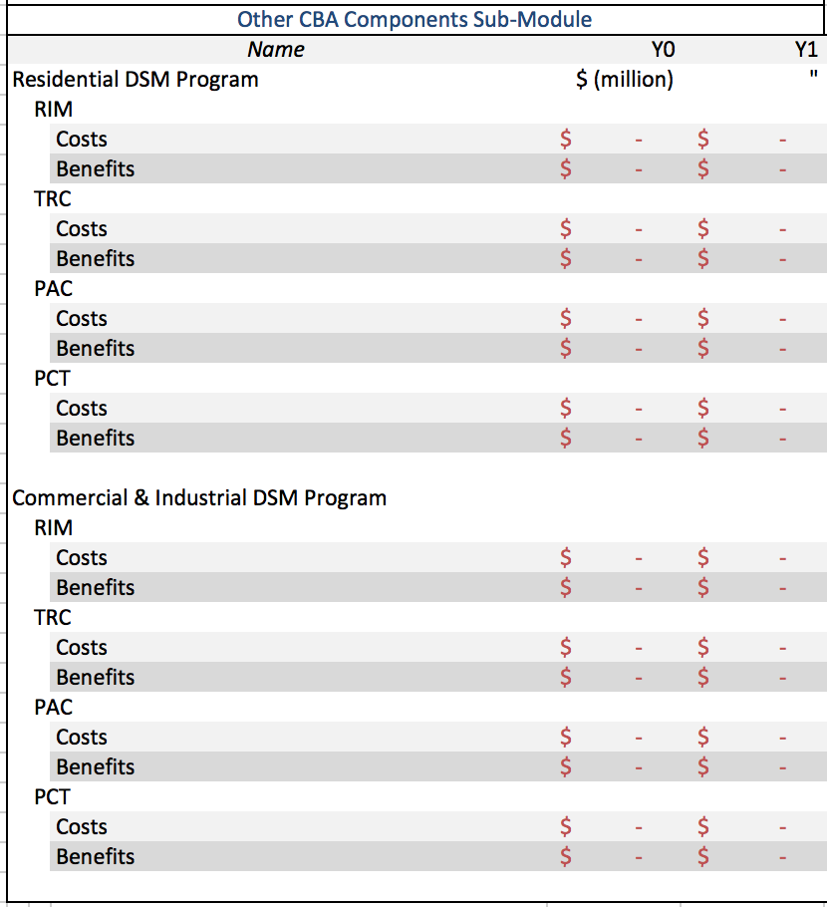

*[TEST] (RIM, TRC, PAC, or PCT):*

Costs:

Units: $ (million)

Description:

This input it asking for any additional costs associated with the program based on the state specific standard practice for each test. This is input is test and customer class specific.

Source: PSC filings or user calculation

Benefits:

Units: $ (million)

Description:

This input it asking for any additional benefits associated with the program based on the state specific standard practice for each test. This is input is test and customer class specific.

Source: PSC filings or user calculation

# Calculations

The calculations for the model are listed within the following section. They are listed by sector, module, and sub-module. Each sub-module contains a brief description of the calculations performed within them and a generalized formula of the calculation.

## Customer Sector

The Customer Sector calculations are split into two parts: the Rate Impact module and the Bill Impact module.

### Rate Impact Module

The calculations for the Rate Impact Module of the Customer Sector focus on different rate mechanisms and energy efficiency impact on rates. It also contains calculations of the levelized cost of energy saved from the energy efficiency.

#### Fundamental Sub-Module

The Fundamental sub-module of the Rate Impact module primarily contains annual projection forecasts. It also includes information pulled from the following sub-modules, but this is simply an aggregation of information from the other calculations. The annual projection forecasts consist of a standard form of growth equation:

*xt = xt-1 * (1 + %AvgChange)*

where *t* is a year index.

There are two notable exceptions to this.

The first exception is the average total rate, which is the sum of the variable and the fixed rate. The variable and the fixed rate are calculated separately and have two different possible methods of calculation. The method can be selected by the “Use Utility Revenue Requirements for Variable Rate” and “Use Utility Revenue Requirements for Fixed Rate” inputs (see 2.1.1.1).

The first method used to calculate the annual variable or fixed rate is simply a standard growth calculation as shown above. The second method for calculating the variable and fixed rate uses the utility revenue requirement in a formula as follows:

*ratet = costt / salest*

The second exception from the standard growth equation is the projection of sales in the energy efficiency case. In each year the sales have the standard growth rate applied but then have the program savings for the year removed. This is shown below:

*salest = [salest-1 * (1 + %AvgChange)] - savingst*

#### Program Cost Recovery Sub-Module

The Program Cost Recovery sub-module of the Rate Impact module contains two different methods for the program costs to be recovered. The method to be used can be selected based on the inputs to this sub-module (see 2.1.1.2).

The first method is a simple expensing method that recovers all of the program costs in the same year in which they are incurred. The formula is simply:

*ratet = costt / salest*

This distributes the recovery of costs evenly across all sales within the customer class.

The second method is to amortize the cost over a given period. The length of the period can be specified in the inputs (again, see 2.1.1.2). The excel built in formula is used. This is done independently for the costs in each program year and then summed across all programs to get the program cost recovery rate in each given year.

#### Lost Revenue Recovery Sub-Module

The Lost Revenue Recovery sub-module of the Rate Impact module contains three different methods for recovering revenue lost due to reduced sales. The method used for this particular analysis can be selected based on the inputs to this sub-module (see 2.1.1.3).

The first method is a lost revenue adjustment mechanism. This calculation is done based on projected savings for the year ahead. It is calculated as follows:

|  |  |  |
| --- | --- | --- |
|  | **Name** | **Calculation** |
| **A** | Fixed Cost Rate | *Input* |
| **B** | Savings | *Input* |
| **C** | Lost Fixed Cost | **A * B** |
| **D** | kWh Sales | *Input* |
| **E** | Lost Revenue Recovery Rate | **C / D** |

The second method is a per customer decoupling mechanism. This method has two different calculations, one at the beginning of the planning period and one at the end of each year. The first is a calculation of authorized revenue per customer. This is simply calculated as follows:

*AuthorizedRevenuePerCustomert = FixedCostRevenueRequirementt / Customerst*

The second calculation is a true-up mechanism to ensure the actual revenue per customer meets the authorized revenue per customer. The calculation is as follows:

|  |  |  |
| --- | --- | --- |
|  | **Name** | **Calculation** |
| **A** | Fixed Cost Rate | *Input* |
| **B** | kWh Sales | *Input* |
| **C** | Customers | *Input* |
| **D** | Actual Revenue per Customer | **(A * B) / C** |
| **E** | Authorized Revenue per Customer | *Calc. Above* |
| **F** | Revenue per Customer Difference | **E - D** |
| **G** | Lost Revenue Recovery Rate | **(F * C) / B** |

The third method is a straight fixed and variable rate mechanism. This method calculates a fixed charge that is applied to each customer regardless of usage and can cover any fraction of the total fixed costs for this class with the rest being recovered through a normal kWh rate. If not all of the fixed cost is recovered this way then it can be paired with another method. The calculation is as follows:

|  |  |  |
| --- | --- | --- |
|  | **Name** | **Calculation** |
| **A** | Fixed Cost Rate | *Input* |
| **B** | Base case kWh Sales | *Input* |
| **C** | % Fixed Cost Recovered as Charge | *Input* |
| **D** | Customers | *Input* |
| **E** | Cost Recovered in Charge | **(A * B) * C** |
| **F** | Cost Recovered in Rate | **(A * B) * (1 – C)** |
| **G** | Straight Fixed Charge | **E / D** |
| **H** | Adjusted Fixed Cost Rate | **F / B** |

#### Levelized Cost of EE Sub-Module

The Levelized Cost of Energy Efficiency sub-module of the Rate Impact module primarily contains discount rate adjustments of the following form:

*PVx = xt / (1 + DiscountRate)t*

Once all the values are converted to present value dollars, the levelized cost is calculated as follows:

|  |  |  |
| --- | --- | --- |
|  | **Name** | **Calculation** |
| **A** | Program Costs | *Input* |
| **B** | Energy Savings | *Input* |
| **C** | Levelized Cost of Energy Efficiency | **A / B** |

#### Fuel Use Shift Sub-Module

The Fuel Use Shift sub-module of the Rate Impact module is a more complicated sub-module. As input, it takes some information on the distribution of the savings and the marginal and average cost of energy production for the peak and off-peak periods. Using this information the sub-module calculates the average fuel cost for the on-peak and off-peak periods using the following method:

|  |  |  |
| --- | --- | --- |
|  | Name | Calculation |
| A | Period Sales | *Input* |
| B | Period Average Fuel Cost (Base Case) | *Input* |
| C | Base Fuel Cost | **A * B** |
| D | Period Savings | *Input* |
| E | Period Average Marginal Fuel Cost | *Input* |
| F | Marginal Fuel Cost Savings | **(E – B) * D** |
| G | EE Case Fuel Cost | **C - F** |
| H | Period Average Fuel Cost | **G / A** |

The percent different between the average fuel cost calculated above and the average fuel cost in the base case is then applied to the growth rate of the fuel cost portion of the rate for all customer classes.

#### EE Measure Targeting Sub-Module

The Energy Efficiency Measure Targeting sub-module of the Rate Impact module simply adds the targeting program costs to the energy efficiency program costs and adjusts the savings, both energy and demand, by the percent input (see 2.1.1.6).

### Bill Impact Module

The calculations for the Bill Impact Module of the Customer Sector focus on determining the average monthly bill paid by consumers in the customer class with different methods to calculate bills for program participants and non-participants. It also contains calculations to account for possible differences in usage between participants and non-participants before introduction of the energy efficiency programs.

#### Fundamental Sub-Module

The Fundamental sub-module of the Bill Impact module contains an annual projection forecast of the number of customers. This projection is done using the standard projection:

*Customerst = Customerst-1 * (1 + %AvgChangeCustomers)*

This information is then used, with some inputs from the Rate Impact module, to calculate average use and average bill as follows:

|  |  |  |
| --- | --- | --- |
|  | **Name** | **Calculation** |
| **A** | Sales | *Input* |
| **B** | Number of Customers | *Input* |
| **C** | Average Use | **A / B** |
| **D** | Total Rate | *Input* |
| **E** | Average Bill | **(C / 12) * D** |

#### Participation Sub-Module

The Participation sub-module of the Bill Impact module uses the average usage in the base case for non-participating customers and determines the usage of participants as follows:

|  |  |  |
| --- | --- | --- |
|  | **Name** | **Calculation** |
| **A** | Number of Participants | *Input* |
| **B** | Savings | *Input* |
| **C** | Savings per Participant | **B / A** |
| **D** | Average Non-Participant Usage | *Input* |
| **E** | Average Participant Usage | **D - C** |

The average bill is then calculated the same as before (see 3.2.1.2).

#### Difference in Participant Average Use Sub-Module

The Difference in Participant Average Use sub-module of the Bill Impact module uses the same method as the Participants sub-module (see 3.1.2.2) to calculate the average participant usage except that the amount entered as the “Difference in Participant Average Use” (see 2.1.2.3) is added to the average participant usage. Once this is done, the average non-participant usage is calculated as follows:

|  |  |  |
| --- | --- | --- |
|  | **Name** | **Calculation** |
| **A** | Sales | *Input* |
| **B** | Average Participant Usage | *Input* |
| **C** | Number of Participants | *Input* |
| **D** | Total Non-Participant Usage | **A – (B * C)** |
| **E** | Number of Non-Participants | *Input* |
| **F** | Average Non-Participant Usage | **D / E** |

## Utility Sector

The Utility Sector calculations are split into three parts: the Fundamental module, the Performance Incentive module, and the Deferred Capital Investment module.

### Fundamental Sub-Module

The Fundamental Sub-Module of the Utility Calculations calculates values for major cost-of-service categories within electric power supply.

Values for energy sales (kWh) are borrowed from the Customer Calculations.

Forecasts of peak load are calculated using the following formula:

$${Annual Peak Load}_{t}=\frac{{Sales}_{t}}{{Annual Load Factor}_{0}*8760hours}$$

Where

$$Annual Load Factor=\frac{Average Annual Load}{Annual Peak Load}$$

This calculation uses the user-input annual load factor for year zero - ${Annual Load Factor}_{0}$- to transform average annual load into peak annual load. Average annual load is computed by dividing the annual sales - ${Sales}_{t}$– by 8760 hours to convert annual kWh (energy) to average annual kW (load).

**Variable Costs**

Variable Costs are calculated so as to account for the distribution of peak and off-peak sales, the differences in costs of production during peak periods vs. during off-peak periods, and the change in sales that occur under the DSM scenario.

Annual peak and off-peak costs of production are calculated using the growth formula common throughout this analysis. An example with peak costs is given below:

$${Peak Costs of Production}_{t}={Peak Costs of Production}_{t-1}*(1+Peak Cost Growth Rate)$$

Average Costs of Production are calculated as a weighted average of the Peak Costs of Production and the Off-Peak Costs of Production, weighted by Peak Sales and Off-Peak Sales, respectively. The Average Costs of Production are calculated for each year, and for the DSM and BAU scenarios, as follows:

|  |  |  |
| --- | --- | --- |
|  | **Name** | **Calculation** |
| **A** | Peak Costs of Production | *Input* |
| **B** | Off-Peak Costs of Production | *Input* |
| **C** | Residential Peak Sales | *Input* |
| **D** | Residential Off-Peak Sales | *Input* |
| **E** | Commercial Peak Sales | *Input* |
| **F** | Commercial Off-Peak Sales | *Input* |
| **G** | Average Costs of Production | ((A*(C+E))+(B*(D+F))/(C+E+D+F) |

The overall costs of production for the DSM scenario and the BAU scenario are calculated for each customer class by multiplying the Average Costs of Production with the total sales for each customer class.

**Fixed Costs**

The Fixed Cost calculations determine the fixed cost revenue requirement, which is the revenue requirement of energy supply that cannot be attributed to variable costs of production. The fixed cost revenue requirement categories include:

* Interest on Debt Revenue Requirement
* Return on Equity (ROE) Revenue Requirement
* Tax Revenue Requirement
* Annual Fixed Operations and Maintenance Costs[34]
* Annual Depreciation Revenue Requirement
* Performance Incentives (if any apply)

The Rate Base for the given year is calculated as the Asset Basis for Depreciation minus the Total Book Depreciation Reserve and Total Tax Depreciation Reserve, to account for depreciation in asset value calculated by the utility firm.

The Total Book Depreciation Reserve is the sum of all Annual Depreciation on Asset (Book) Basis to-date. That is,

$${Total Book Depreciation Reserve}_{Y}= \sum_{0}^{t=Y}{{Annual Depreciation on Asset \left(Book\right)Basis}_{t}}$$

Where $Y$ is the current year.

The Annual Depreciation on Asset (Book) Basis is the product of the Asset Basis for Depreciation in the given year and the Book Depreciation Rate input by the user.

The Total Tax Depreciation Reserve is the sum of all Annual Depreciation on Tax Basis to-date. That is,

$${Total Tax Depreciation Reserve}_{Y}= \sum_{0}^{t=Y}{{Annual Depreciation on Tax Basis}_{t}}$$

The Annual Depreciation on Tax Basis is the product of the Asset Basis for Depreciation in the given year and the Tax Depreciation Rate input by the user.

The Asset Basis for Depreciation in a given year is the sum of the Year-Zero Rate Base and the sum of all Annual Capital Expenditure from Year Zero to the given year, as in

$${Asset Basis for Depreciation}_{Y}= {Rate Base}_{0}+\sum_{0}^{t=Y}{{Annual Capital Expenditure}_{t}}$$

Where ${Rate Base}_{0}$ is the initial Rate Base input by the user, ${Annual Capital Expenditure}_{t}$ is the capital expenditure in year $t$, and $Y$ is the current year.

Annual Capital Expenditure is calculated as a combination of two factors: (1) a growth-forecast of the Year-Zero Annual Capital Expenditure input by the user, and (2) the sum of major capital investments in the given year according to the capital investments input by the user. This is expressed as

$${Annual Capital Expenditure}_{Y}={Annual Capital Expenditure}_{Y-1}*\left(1+Capital Expenditure Growth Rate\right)+\sum_{A}^{i=E}{{Annual Capital Investment}_{i}}$$

Where $i=A, B, C, D, E$ is the index of all capital investment projects input by the user (see Capital Investment Deferral sub-module under Utility Sector). Capital Expenditure Growth Rate is input by the user.

The Annual Debt of the utility is calculated as the Rate Base of the given year times the Percent Debt input by the user in the Utility Sector. The Annual Equity is calculated as the Rate Base of the given year times the Percent Equity input by the user in the Utility Sector.

The Annual Interest Revenue Requirement is calculated as the Annual Debt of the utility times the Cost of Debt input by the user in the Utility Sector. The Annual ROE Revenue Requirement is calculated as the Annual Equity times the Target ROE input by the user.

The Tax Revenue Requirement is calculated as follows:

$${Tax Revenue Requirement}_{t}=\left(\frac{{Return on Equity Revenue Requirement}_{t}}{1-Effective Income Tax Rate}\right)-{Return on Equity Revenue Requirement}_{t}$$

The Annual Operations and Maintenance Expenditure is calculated via a growth formula analogous to that used for sales, making use of the user’s inputs for year-zero Operations and Maintenance Expenditure and the growth rate for Operations and Maintenance Expenditure.

The Residential Fixed Cost Revenue Requirements are calculated by multiplying the overall Fixed Cost Revenue Requirements by the Rate Class’s Share of Fixed Costs input by the user in the Residential Sector.

The Commercial Fixed Cost Revenue Requirements are calculated by multiplying the overall Fixed Cost Revenue Requirements by the Rate Class’s Share of Fixed Costs input by the user in the Commercial Sector.

**Utility Annual Operating Expenses**

The Utility Costs are calculated for the DSM case and BAU case separately as the sum of Variable Costs – the Total Costs of Production (see Variable Costs sub-heading above) – and Fixed Costs, which is the sum of the Annual Interest on Debt, the Annual Operations and Maintenance Costs, and the Annual Depreciation Revenue Requirement.

**Return on Equity**

The After-Tax Earnings are calculated for the DSM case and BAU case separately as follows:

|  |  |  |
| --- | --- | --- |
|  | **Name** | **Calculation** |
| **A** | Residential Sales | *Calculated by Model* |
| **B** | Commercial Sales | *Calculated by Model* |
| **C** | Residential Energy Rate | *Calculated by Model* |
| **D** | Commercial Energy Rate | *Calculated by Model* |
| **E** | Commercial Demand Rate | *Calculated by Model* |
| **F** | Annual Peak Load Forecast | *Calculated by Model* |
| **G** | Utility Costs | *Calculated by Model* |
| **H** | Effective Income Tax Rate | *Input* |
| **F** | After-Tax Earnings | **{(A*C)+(B*D)+(F*E*12)G}*(1-H)** |

The Return on Equity is the After-Tax Earnings divided by the Total Equity (see Fixed Costs subheading above).

**ROE Breakdown Outputs**

These calculations are intended to display components of the ROE outputs that are made up of DSM cost recovery mechanisms, such as Lost Revenue Recovery, Program Cost Recovery, and Performance Incentives. Non-DSM-Cost-Recovery ROE is the total ROE minus contributions from DSM cost-recovery mechanisms, which are calculated in the Customer Calculations.

### Performance Incentive Sub-Module

The performance incentive calculations are only triggered if the user has activated the incentive in the Utility Sector (see Utility Sector 2.2.2 for details on how to do this). The base incentive value is calculated by multiplying the value on which the incentive is based by the percent of that value that is authorized to be returned to the utility.

This base value can be adjusted based on various incentive limits. These are an incentive cap, a performance threshold, and grossed savings. The incentive cap allows for a different value to be selected and to limit the incentive to some portion of that value. An example would be to allow the recovery of an incentive based on savings but to limit it to some percentage of the program costs.

The performance threshold is a limit on the incentive based on a threshold that must be met. This simply compares the value that the program achieves for a given value and the amount that is entered as the threshold. If the program achieves less than the threshold, the base incentive amount is multiplied by the percent allowed when the threshold is not met (an input). When the threshold is met the base incentive amount is recovered as per normal.

The grossed savings is an adjustment on the amount of savings awarded for the purpose of calculating the incentives. The net-to-gross percentage is multiplied by the program savings before the base incentive calculation is done and involves no comparison or calculation after the base incentive is calculated.

### Deferred Capital Investment Sub-Module

The calculations of the Deferred Capital Investment sub-module show the number of years by which capital investment projects could be deferred. The key assumption to the Deferred Capital Investment sub-module is that capital investments are contingent in their timing upon the peak load. That is, the utility firm’s decision to make capital investments is driven by the peak load it foresees in the future, and mitigation of increases in peak load enables the utility to postpone such capital investments. The descriptions that follow apply to all capital investment projects input by the user.

The “Load at Activation Year Without EE” is calculated by identifying the peak load that occurs in the BAU case at the Activation Year input by the user.

The “Next Year at Which EE Load Reaches no EE Activation Year Load” is calculated by identifying the year in the DSM case at which peak load meets or exceeds the Load at Activation Year without EE.

The “Difference from Original Activation Year” is calculated by taking the difference between the “Next Year at Which EE Load Reaches no EE Activation Year Load” and the Activation Year input by the user.

The “Years in Time Series, Adjusted for Deferral” are calculated by subtracting the “Difference from Original Activation Year” from the year index time series. The year index time series is all integers starting at 0 and going to 25, representing the 25 years in the forecast period. For example, if the “Difference from Original Activation Year” is equal to 4, “Years in Time Series, Adjusted for Deferral” is all integers starting at -4 and going to 21.

The “Costs in Time Series, Adjusted for Deferral” are calculated by matching the cost value for a given year input by the user in the Utility Sector Deferred Capital Investment sub-module with the corresponding year index in “Years in Time Series, Adjusted for Deferral.” For example, if the user entered $1,000 in year 6, and the “Difference from Original Activation Year” is 4, the $1,000 for year 6 appears in year 10 in the “Costs in Time Series, Adjusted for Deferral.”

The values in “All Capital Investments” are the corresponding costs of each capital investment project for the given year under the BAU case and the DSM case.

## Cost-Benefit Analysis

The Cost-Benefit Analysis (CBA) calculations are intended to transform the Customer Calculations and the Utility Calculations into expressions of impacts to stakeholders. These expressions are taken from the California Standard Procedures Manual[35] and are widely used throughout the electric utility industry. These four tests[36] are:

* The Ratepayer Impact Measure (RIM) test, which identifies the extent to which electric power rates will increase due to the deployment of a given resource option.
* The Participant Cost Test (PCT), which weighs the costs and benefits to those adopting distributed resource options or participating in utility DSM programs.
* The Program Administrator Cost Test (PAC or PACT, sometimes called the Utility Cost Test), which weighs the costs and benefits to the utility firm seeking to deploy the given resource option or program
* The Total Resource Cost Test (TRC), which estimates the net benefits of the resource option to both the utility firm and its ratepayers.

The CBA calculations are each a net-present value (NPV) calculation. As such, each requires a discount rate to reflect the time-value of money. The PCT uses a default discount rate of 10%, while the other three tests use the utility’s WACC by default. This difference is meant to reflect greater risk aversion on behalf of customers in comparison to the risk aversion of utilities’ creditors. The user may change these values in the Cost-Benefit Analysis Sector of the model’s inputs.

**Cost-Benefit Analysis Test Formulas**

Each Cost-Benefit Analysis test uses a different formula for computing the net benefits of the DSM program. This section identifies the respective cost categories and benefit categories used in GT-DSM for each test.

|  |  |  |
| --- | --- | --- |
| **Test Name** | **Benefit Categories** | **Cost Categories** |
| **RIM** | Avoided Supply Costs | Utility Costs of EE program; Reduced Revenues to Utility |
| **TRC** | Avoided Supply Costs | Utility Costs of EE program; Participant Measure Costs |
| **PAC** | Avoided Supply Costs | Utility Costs of EE program |
| **PCT** | Customer Bill Savings;  Incentives Received | Participant Measure Costs |

While the results of these tests are displayed within the model, these descriptions will focus on the calculations necessary to arrive at the CBA test results.

Customer Bill Savings

The Customer Bill Savings is calculated as the product of the total number of customers and the difference between the average customer bill in the BAU case and the average customer bill in the DSM case.

Participant Measure Costs

The Participant Measure Cost is the product of the Program Savings and the Weighted Average EE Program Cost per kWh-avoided. Both of these are user inputs. The Weighted Average EE Program Cost per kWh-avoided are input in the CBA analysis sheets and can be input separately for each customer class.

Utility Cost of EE Program

Utility Administrative Costs is taken from the user inputs of EE program costs in the Customer Sector.

Incentives Paid is taken as an input from the user in the Customer Sector.

Incentives Received

Incentives Received are calculated as equivalent to the Incentives Paid under the Utility Costs of EE Program section

Reduced Revenues to Utility

Reduced Revenues to Utility are calculated as equivalent to the Customer Bill Savings

Avoided Supply Costs

Avoided Supply Costs are calculated from other calculated values in the Utility Calculations. They are calculated as follows:

|  |  |  |
| --- | --- | --- |
|  | **Name** | **Calculation** |
| **A** | Annual On-peak Savings | *Input* |
| **B** | On-peak Costs of Production | *Input* |
| **C** | Total Costs of Peak Production | *A*B* |
| **D** | Annual Off-peak Savings | *Input* |
| **E** | Off-peak Costs of Production | *Input* |
| **F** | Total Costs of Off-peak Production | *D*E* |
| **G** | Total Avoided Supply Costs | **C+F** |

# Outputs

The outputs for the model are listed within the following section and contain a brief description with a breakdown of the inputs and calculations that apply. The data listed in the images are based on one or more Southeastern utilities and should only be considered examples of possible data.

## Customer Sector

The Customer Sector outputs are split into two parts: outputs from the Rate Impact module and outputs from the Bill Impact module.

### Rate Impact Module

The Rate Impact Module outputs shows a comparison of rates in the base case and the energy efficiency case, a breakdown of the rate components in the energy efficiency case, and information on the levelized cost of energy efficiency.

The first set of outputs, % Rate Difference and Rate Impact Breakdown, are a look at the difference in rates between the base case and the energy efficiency case. Both can be seen below (Figure 1).

Figure : Percentage change in rate in the analyzed case versus the base case and the breakdown there of

The first graph, Percent Rate Difference, shows the difference in the electricity rate between the base case and the energy efficiency case as a percent of the base case rate. Positive percentages are an increase in rates over the base case and negative percentages are a decrease in rates over the base case. This difference is shown for all years of the analysis.

The second graph, Rate Impact Breakdown, shows the various factors that add up to make the percent rate difference between the base case and the energy efficient case. The different factors shows are the incentive, the shift in use, recovery of lost fixed cost, and recovery of program costs. Each are shown in their entirety for the all years of the analysis.

The second set of outputs, Rate Comparison and Rate Breakdown, are a look at the actual rates. First is a look at the actual rates in both cases and second a breakdown of the efficiency case rates. Both can be seen below (Figure 2).

Figure 2: Third Rate Impact Module output graph

The first graph, Rate Comparison, shows both the base case and energy efficiency case rates side by side for each year of the analysis. The point of showing this as well as the graph of percentage difference in rates is to give a sense of scale and show the overall trend of rates.

The second graph, Rate Breakdown, shows the value of each component that makes up the electricity rate in the analysis. Any that are not used will still appear in the legend but will simply be blank in the actual chart. This information is shown for each year of the analysis.

The third category of output from the Rate Impact module is the levelized cost of energy efficiency. All values shown include the cost of the energy efficiency program and the energy savings valued at the variable cost rate.

The first output is a single aggregated levelized cost value for all years of the program for the customer class.



Figure 3: Fourth Rate Impact Module output

The second output for levelized cost of electricity saved in the Rate Impact module shows the levelized cost for each year of the program. These values take into account the full lifetime of the measures installed in each year of the program.

Figure 4: Fifth Rate Impact Module output graph

### Bill Impact Module

The Bill Impact Module outputs show (a) the average difference between bills in the base case and the energy efficiency case, (b) cumulative bill savings in the energy efficiency case as opposed to the base case, (c) a comparison of the average bill difference between participants and non-participants, and (d) the portion of all customers in the customer class that end up participating in the program.

The first output from the Bill Impact Module shows the difference between the average bill of all customers in the customer class in the base case and the energy efficiency case as a percent of the base case average bill. Positive percentages are an increase in bills over the base case and negative percentages are a decrease in bills over the base case. This difference is shown for all years of the analysis.

Figure 5: First Bill Impact Module output graph

The second output from the Bill Impact Module shows the total cumulative bill savings for all customers in the customer class across all years of the analysis. The value is in year zero dollars, calculated using the discount rate from the Levelized Cost of Energy Efficiency sub-module (see 2.1.1.4).



Figure 6: Second Bill Impact Module output

The third output from the Bill Impact Module shows the percentage change of average bills from the base case to the energy efficiency case for participants, non-participants, and all customers in the customer class. Positive percentages are an increase in bills over the base case and negative percentages are a decrease in bills over the base case. This difference is shown for all years of the analysis.

Figure 7: Third Bill Impact Module output graph

The fourth and final output from the Bill Impact Module shows the number of customers projected in the analysis as well as the number and proportion of participating customers.

Figure 8: Fourth Bill Impact Module output graph

## Utility Sector

The Utility Sector outputs are split into two parts: outputs from the Utility Impact module and outputs from the Capital Investment Deferral module.

### Utility Impact Module

The Utility Impact Module outputs show a comparison of earnings and return on equity in the base case and the energy efficiency case, a breakdown of the benefits to earnings of various rate mechanisms in the energy efficiency case, and a breakdown of the cost of production in the energy efficiency case.

The first output from the Utility Impact module shows the after tax earnings for the base case and the energy efficiency case. This shows purely the actual dollar amount of profit in both cases over the duration of the analysis.

Figure 9: First Utility Impact Module output graph

The second output from the Utility Impact module shows the Return-on-Equity (ROE) for both the base case and the energy efficiency case. This output serves to adjust for differences in investment between the two cases. There may be a reduction in after-tax earning with no corresponding reduction in ROE. The information is shown annually for the duration of the analysis.

Figure 10: Second Utility Impact Module output graph

The third output from the Utility Impact module shows a breakdown of the benefits to earnings from different cost recovery mechanisms and utility incentives. The three mechanisms are program cost recovery, recovery of lost revenue, and incentive mechanisms. The chart shows the range by which the utility might underachieve if these mechanisms weren’t in place. Any mechanisms that are not used will still appear in the legend but will simply be blank in the actual chart. This information is shown for each year of the analysis.

Figure 11: Third Utility Impact Module output graph

The fourth and final output from the Utility Impact module shows a breakdown of the total cost of production. The cost of production for both cases and the fixed cost revenue requirement is shown.

Figure 12: Fourth Utility Impact Module output graph

### Capital Investment Deferral Module

The Capital Investment Deferral Module outputs show a comparison of plant investment schedules in the base case and the energy efficiency case. The values used here are shown as an example.

Both outputs from the Capital Investment Deferral module show the year and amount to be invested in specified plant. The first shows the base schedule as entered in the Utility Sector Deferred Capital Investment module (see 2.2.2). The second shows the investment schedule based on the reduced demand from the energy efficiency program.

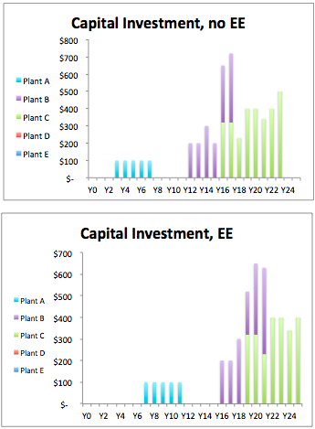

Figure 13: Capital Investment Deferral Module output graphs

## Cost-Benefit Analysis Sector

The Cost-Benefit Test outputs display the calculated results for each of four CBA tests, the breakdown of costs and benefits, and some information on how they compare to the utility values.

In the first graph, CBA Test Result Comparison, the results are displayed in terms of the NPV of the first 10 years of net benefits[37] and the full 25 years of net benefits. Alongside these values is show the utility values to get a sense for how close or far these values are from each other.

Figure : Comparison across time horizons and source

In the next graph, CBA % Difference, shows the percent that the 25 years of net benefits is different from the utility value. This is calculated as a percent of the utility CBA value. If no utility values were entered for the CBAs, this output would be blank.

Figure : Difference between the utility CBA values and the tool CBA values

The final graph, CBA Result Breakdown, shows the 25 years of benefits and costs of for each of the test that result in the net benefits shown above.

Figure : Value for 25-year benefits and costs for each CBA test

# References

Brown, M. A., Staver, B. E., & Smith, A. (2014). Expanded Capacity for Modeling Energy Efficiency in the Southeast: Project Summary. Southface Institute.

Cappers, P., Goldman, C., Chait, M., Edgar, G., Schlegel, J., & Shirley, W. (2009). Financial Analysis of Incentive Mechanisms to Promote Energy Efficiency : Case Study of a Prototypical Southwest Utility. Ernest Orlando Lawrence Berkeley National Laboratory.

ELCON. (2007). Revenue Decoupling. Washington DC: The Electricity Consumers Resource Council.

Gellings, C., Wikler, G., & Ghosh, D. (2006). Assessment of U . S . Electric End-Use Energy Efficiency Potential. *The Electricity*, *19*(9), 55–69. doi:10.1016/j.tej.2006.10.001

Georgia Power Company. (2012a). 2012 Annual Report. Atlanta, GA.

Georgia Power Company. (2012b). Impact Evaluation of Georgia Power Company’s 2011 DSM Programs. Nexant.

Georgia Power Company. (2012c). Achievable Energy Efficiency Potentials. Atlanta, GA: Nexant.

International Performance Measurement & Verification Protocol Committee. (2002). *International Performance Measurement & Verification Protocol Concepts and Options for Determining Energy and Water Savings* (Vol. I). Retrieved from http://www.doe.gov/bridge

Kihm, S. (2009). When Revenue Decoupling Will Work … and When It Won ’ t. *The Electricity Journal*, (October).

National Action Plan for Energy Efficiency. (2008). Understanding Cost-Effectiveness of Energy Effi ciency Programs : Best Practices, Technical Methods, and Emerging Issues for Policy-Makers. Energy and Environmental Economics, Inc. and Regulatory Assistance Project. Retrieved from www.epa.gov/eeactionplan

National Action Plan for Energy Efficiency (NAPEE). (2007). Aligning Utility Incentives with Investment in Energy Efficiency. U.S. EPA. Retrieved from www.epa.gov/eeactionplan

National Renewable Energy Laboratory (NREL). (2013). Chapter 13 : Assessing Persistence and Other Evaluation Issues Cross- Cutting Protocols.

Price, S. (n.d.). *National Action Plan for Energy Efficiency Cost-effectiveness Tests “Current Practice ”* (pp. 3–15). Retrieved from www.epa.gov/eeactionplan

Satchwell, Andrew, Cappers, P., & Goldman, C. (2011). Carrots and Sticks : A Comprehensive Business Model for the Successful Achievement of Energy Efficiency Resource Standards. In E. E. T. Division (Ed.), *ECEEE Summer Study*. Giens, France: Ernest Orlando Lawrence Berkeley National Laboratory.

Satchwell, Andy, & Lawrence Berkley National Laboratory (LBNL). (2013). *Overview of Preliminary Quantitative Results for Southeast Regulatory Policy Exercise*.

State of California Governor’s Office of Planning and Research. (2002). California Standard Practice Manual: Economic Analysis of Demand-Side Programs and Projects.

Wang, Y., & Brown, M. a. (2013, November 26). Policy drivers for improving electricity end-use efficiency in the USA: an economic–engineering analysis. *Energy Efficiency*. Springer. doi:10.1007/s12053-013-9237-3

# Glossary

BAU – Business As Usual: The base case scenario in which the behavior or the utility continues without the program being analyzed

CBA – Cost/Benefit Analysis: A type of economics analysis that focused on the costs and benefits of a program or policy

DSM – Demand Side Management: A term used to reference any resource to manage demand instead of supply. These include Energy Efficiency (EE) and Distributed Generation (DG)

EPRI – Electric Power Research Institute: An electricity industry think tank that conducts research as well as R&D

IRP – Integrated Resource Plan: The plan proposed by a utility in front of the PSC

PSC – Public Service Commission: The state level commission charged with regulating utilities. May also be called Public Utility Commission (PUC) or other similar names.

SEC – Securities and Exchange Commission: The federal level commission in charge of regulating stock markets and companies.

SEC 10-K – Securities and Exchange Commission Form 10-K: A form in which publically traded companies must file an annual report making specific information available. The type of data is specified for each Standard Industry Classification (SIC) type.

Y0 – Year One: This is the year from which base case data is entered. It can also be described as the year before the program that is being analyzed starts. The data does not have to be from the actual year zero but can instead be from the most recent year for which data is available.

1. [bstaver@gatech.edu](mailto:bstaver@gatech.edu)
2. [asmith313@gatech.edu](mailto:asmith313@gatech.edu)
3. [jsibley@southface.org](mailto:jsibley@southface.org)
4. [marilyn.brown@pubpolicy.gatech.edu](mailto:marilyn.brown@pubpolicy.gatech.edu)
5. http://cepl.gatech.edu/drupal/node/69
6. In some utility territories retail sales to other customer classes may be significant, such as agricultural. In this case, the data can be grouped with whichever customer class is more similar.
7. Much of the same information may be found in a utility annual report in a friendlier format.
8. Either ‘Planning Area Hourly Demand’ (search by reporting year) for actual years or ‘Planning Area Forecast Demand’ (search by reporting utility and reporting year) for projected years
9. Planning Area Forecast Demand (search by reporting utility and reporting year)
10. Instead of using filed data, alternative program scenarios can be entered. The tool does not validate the feasibility of these alternative scenarios.
11. This alternative method would allow for testing of ramp up periods and other non-uniform rates of change in programs.
12. Nominal dollars should be used and is the standard in SEC fillings as well as utility forecasting but is not the standard for EIA forecasting, which uses real dollars.
13. This alternative method would allow for testing of ramp up periods and other non-uniform rates of change in programs.
14. Nominal dollars should be used and is the standard in SEC fillings as well as utility forecasting but is not the standard for EIA forecasting, which uses real dollars.
15. This alternative method would allow for testing of ramp up periods and other non-uniform rates of change in programs.
16. This supplementary tool to the GT-DSM tool can be found in the same place.
17. The default value in the model can be used to reduce the intensity of calculations. The lifetime entered represents a program with savings being primarily from lighting and refrigerator and freezer retirement.
18. This refers to a 2013 report by the National Renewables Energy Laboratory on the persistence of savings from energy efficiency measures and programs. Available at <http://www.nrel.gov/docs/fy13osti/53827.pdf>
19. Calculations in the model are based on NAPEE report called Aligning Utility Incentives with Investment in EE (2007)
20. If the peak period entered in ‘Peak Duration’ is larger than that used for cost and capacity then the impacts of the EE program will likely be over estimated and under estimated if the discrepancy is reversed.
21. This can be different from the peak period defined for the purpose of calculating QF Avoided cost and care should be taken.
22. ‘Planning Area Hourly Demand’ (search by reporting year)
23. For example, the database at this link: <http://en.openei.org/datasets/node/903>
24. To fit a line in excel, create a chart containing a scatter plot of system lambda versus system demand from the FERC 714 Schedule 2. From this plot, create a trendline to get the marginal cost curve. This can be done using the Trendline tool under Analysis in excel (<http://office.microsoft.com/en-us/excel-help/add-change-or-remove-a-trendline-in-a-chart-HP010007461.aspx>). 3 years of data is the norm but more or less can be used with good rational.
25. These represent the marginal costs of production for each hour of the year
26. QF Avoided Cost values should serve and help maintain consistency with the utility. However, if there are strong reasons to believe that the QF Avoided Cost values are inaccurate, users are encouraged to use FERC Form 714 hourly system lambda data.
27. These represent the marginal costs of production for each hour of the year
28. To fit a line in excel, create a chart containing a scatter plot of system lambda versus system demand from the FERC 714 Schedule 2. From this plot, create a trendline to get the marginal cost curve. This can be done using the Trendline tool under Analysis in excel (<http://office.microsoft.com/en-us/excel-help/add-change-or-remove-a-trendline-in-a-chart-HP010007461.aspx>). 3 years of data is the norm but more or less can be used with good rational.
29. QF Avoided Cost values should serve and help maintain consistency with the utility. However, if there are strong reasons to believe that the QF Avoided Cost values are inaccurate, users are encouraged to use FERC Form 714 hourly system lambda data.
30. These represent the marginal costs of production for each hour of the year
31. This alternative method would allow for testing of ramp up periods and other non-uniform rates of change in the program.
32. These represent the marginal costs of production for each hour of the year
33. QF Avoided Cost values should serve and help maintain consistency with the utility. However, if there are strong reasons to believe that the QF Avoided Cost values are inaccurate, users are encouraged to use FERC Form 714 hourly system lambda data.
34. O&M can be divided into fixed and variable portions. The fixed portion is used in the calculations of fixed revenue requirements, while the variable portion is used in the calculations of variable revenue requirements.
35. http://www.energy.ca.gov/greenbuilding/documents/background/07-J_CPUC_STANDARD_PRACTICE_MANUAL.PDF
36. The Societal Resource Cost test (SRC) is omitted from this model because societal impacts are difficult to quantify and generally have not become a key point of discussion in state-level regulatory dialogues concerning ratepayer-funded energy efficiency programs.
37. Two different time horizons are used in displaying the NPV results of the CBA tests because some utility programs report short time horizons, such as 10 years, even though the measures deployed in those 10 years are likely to continue delivering savings long after the 10 years have expired.